# **CTF Topic: Network Scanning- Using DNS Checker**

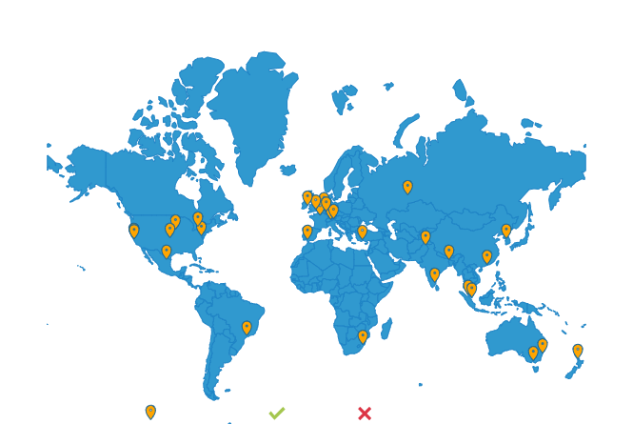

# **Introduction**

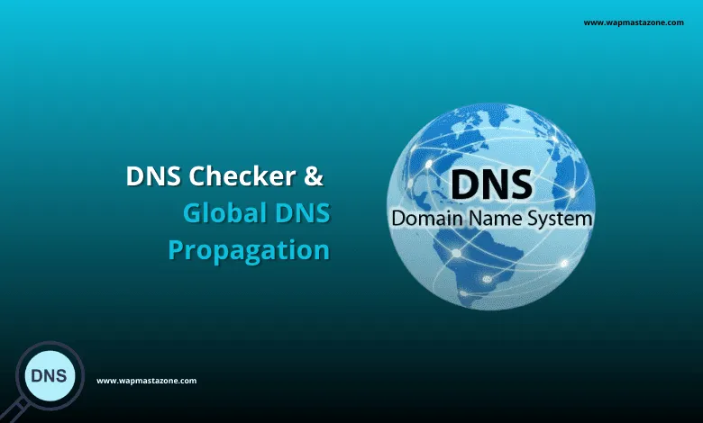

In this CTF challenge, you'll explore how the Domain Name System (DNS) works by performing various tasks related to DNS lookups. DNS is a fundamental part of the internet, translating human-friendly domain names into IP addresses that computers use to identify each other on the network.

# **Tools and requirements**

A computer with internet access

DNS lookup tools(DNS checker)

Basic understanding of DNS records and types

# **Scenario**

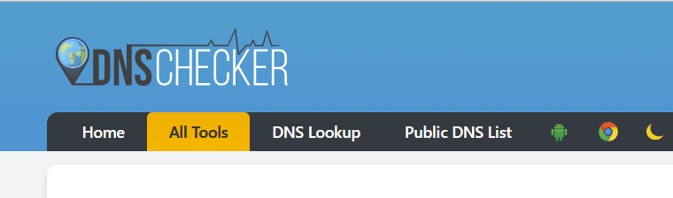

You are a network administrator who has been assigned the task of verifying the DNS records for the domain "example.com". You need to ensure that all the DNS records are correctly set up and there are no discrepancies.

# **Process to Perform**

Step 1: Open the browser and click on the provided link: <https://dnschecker.org/>

Step 2: search for [islington.edu.np](http://www.islingtoncollege.edu.np)

Step 3: Solve the CTF.

# 

# **Let’s start the Challenge**

# **5. Question**

# Perform the following tasks using your preferred DNS lookup tool. Document your findings for each task.

Flag 1 What is the IP address of the target website?

Answer: 172.67.207.245

Flag Captured

Flag 2 What text records (TXT) are associated with the 'islington.com'?

Answer: Ms=ms35163953

Flag Captured

# **5.Hint**

